**Binary Adder- Subtractor**

**The addition and Subtraction operations can be combined into one common circuit by including an exclusive –OR gate with each full adder.**



**Fig: 4-7 shows 4-bit adder-subtractor. The mode input M controls the operation. When M=0 the circuit becomes an adder and when M=1 the circuit becomes a subtractor. When M=0,**



**The full-adder receives the value of B, the input carry is 0 and the circuit performs A plus B.**

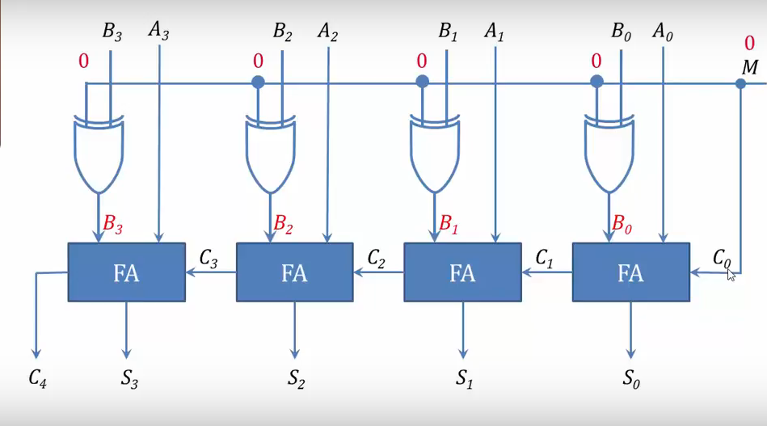



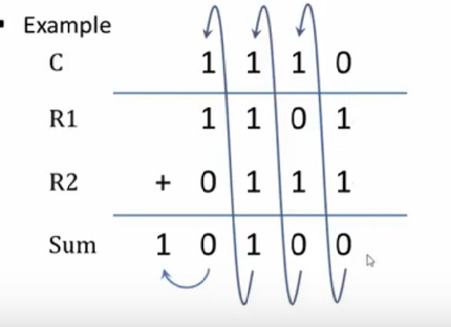



**Here Register R1 contains bits A3 A2A1A0  and R2 contains bits B3 B2B1B0**

**When M=1,**



**The B inputs are all complemented and 1 is added through the input carry. The circuit performs the operation A plus the 2’s complement of B.**

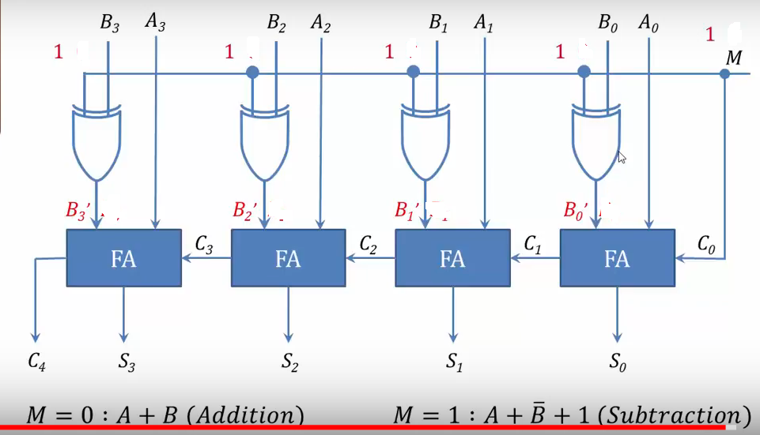

For unsigned numbers, this gives A-B if A≥B or the 2’s complement of (B-A) if A<B.



For signed numbers, the result is A-B because there is no overflow.

Example: A=1111 (Decimal 15)B=1001 (Decimal 9) Here A>B



Here A= 1111 , B’=0110 and A+B’+1=



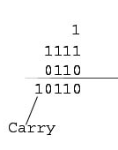Another Example A=1001(Decimal 9) B=1111(Decimal 15) Here A<B



A=1001 B=1111 B’=0000



A+B’+1=



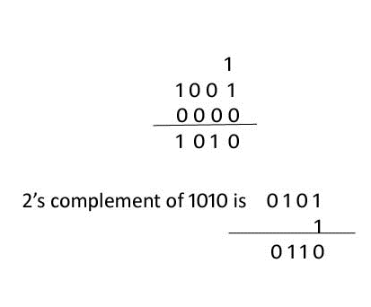So 9-15= - 6

